SSCS – Daily Science Report

Ship: M/V Seahorse
Name: Heidy M. & Diana R.
Date: 14/06/2026
Activity: Monitoring

Small boat monitoring was conducted on June 14th from 00:00 to 23:00, except 17:00, using radar and visual observations. The hours not listed indicate periods when no small boats were detected inside or outside the ZTA.

Hour | Small Boats Inside ZTA
Hour | Total | Net Fishing | Divers | Potential Net Fishing | Crossing
14:00 | 1 | 0 | 0 | 0 | 1

Hour | Small Boats in the ZTA Extension
Hour | Total | Net Fishing | Divers | Potential Net Fishing | Crossing
06:00 | 1 | 0 | 0 | 0 | 1
07:00 | 1 | 0 | 0 | 0 | 1
15:00 | 1 | 0 | 0 | 0 | 1

Hour | Small Boats in the Buffer Zone
Hour | Total | Net Fishing | Divers | Potential Net Fishing | Crossing
06:00 | 1 | 0 | 0 | 1 | 0
07:00 | 1 | 0 | 0 | 1 | 0
08:00 | 1 | 0 | 0 | 1 | 0
09:00 | 1 | 0 | 0 | 1 | 0
21:00 | 1 | 0 | 0 | 1 | 0
22:00 | 1 | 0 | 0 | 1 | 0

Hour | Small Boats in the Vaquita Refuge
Hour | Total | Net Fishing | Divers | Potential Net Fishing | Crossing
00:00 | 1 | 0 | 0 | 1 | 0
05:00 | 2 | 0 | 0 | 2 | 0
06:00 | 3 | 0 | 0 | 3 | 0
07:00 | 3 | 0 | 0 | 0 | 3
08:00 | 9 | 0 | 0 | 5 | 4
09:00 | 15 | 0 | 0 | 14 | 1
10:00 | 20 | 0 | 0 | 20 | 0
11:00 | 1 | 0 | 0 | 1 | 0
14:00 | 1 | 0 | 0 | 0 | 1
15:00 | 7 | 0 | 0 | 3 | 4
16:00 | 12 | 0 | 0 | 9 | 3
18:00 | 3 | 0 | 0 | 0 | 3
19:00 | 8 | 0 | 0 | 4 | 4
20:00 | 5 | 0 | 0 | 5 | 0
21:00 | 1 | 0 | 0 | 0 | 1
22:00 | 4 | 0 | 0 | 2 | 2
23:00 | 3 | 0 | 0 | 3 | 0

Total number of different small boats observed Net Fishing today in the ZTA: 0.

Total number of different small boats observed Net Fishing today in the ZTA Extension: 0.

Total number of different small boats observed Net Fishing today in the ZTA Buffer Zone: 0.

The first small boat activity was observed at 00:00 in the Vaquita Refuge, which was also the area that showed the highest level of small boat activity, peaking at 10:00. In contrast, inside the ZTA, only a single small boat was observed and recorded at 14:00. Small boat activity was recorded in all monitored zones throughout the day. The last small boat activity of the day was observed at 23:00 in the Vaquita Refuge.

Figure 1. Small fishing boat activity within the ZTA on June 14th.

Figure 2. Small fishing boat activity within the ZTA Extension on June 14th.
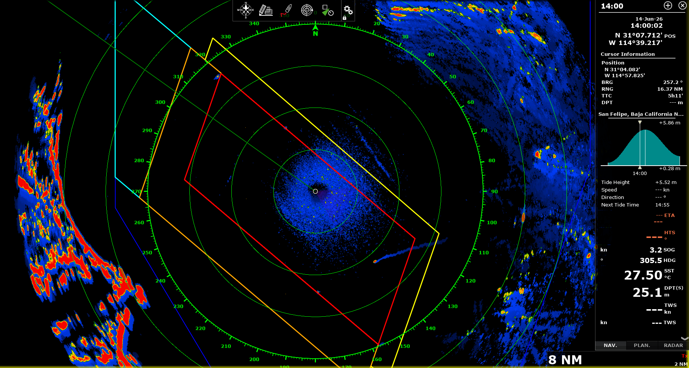
Figure 3. Radar screenshot at 14:00 showing a small boat crossing inside the ZTA and the Vaquita Refuge.

